THAKUR COLLEGE OF SCIENCE AND COMMERCE

Department of Artificial Intelligence and Machine Learning

PROJECT DOCUMENTATION

AI MAZE ESCAPE
An AI-Based Maze Game Using A* Pathfinding Algorithm

Submitted By

Name : Avni Singh
Roll No. : 263607

Class : B.Sc. Artificial Intelligence and Machine Learning
(II YEAR)

Subject : Basics of Artificial Intelligence
Academic Year : 2026–2027

Sr. No | Topic | Page No.
1 | Introduction | 3
2 | Objectives | 4
3 | Software Requirements | 5
4 | A* Search Algorithm | 6
5 | Project Workflow | 7
6 | Screenshots | 8-9
7 | Advantages | 10
8 | Limitations | 10
9 | Future Scope | 10
10 | Conclusion | 11
11 | References  INTRODUCTION  AI Maze Escape is a maze-based game developed using Python and the Pygame library. The objective of the game is to guide the player through different maze levels while avoiding an AI-controlled enemy. The enemy uses the A* (A-Star) search algorithm to calculate the shortest path to the player in real time, making the gameplay more challenging. The project demonstrates the practical application of Artificial Intelligence concepts, pathfinding algorithms, and game development in an interactive environment | 12

OBJECTIVES
The main objectives of this project are:
- To develop an interactive maze game using Python and Pygame.
- To implement the A* (A-Star) pathfinding algorithm for intelligent enemy movement.
- To demonstrate the practical application of Artificial Intelligence in game development.
- To provide multiple levels with increasing difficulty.
- To improve problem-solving, programming, and game development skills.

SOFTWARE REQUIREMENTS

Software | Purpose
Python | Programming Language
Pygame | Game Development Library
IDLE | Writing and Running the Code
Git | Version Control
GitHub | Code Repository
Windows Operating System | Platform for Development

A* SEARCH ALGORITHM

The A* (A-Star) Search Algorithm is an informed search algorithm used to find the shortest path between two points. In this project, it is used by the enemy to continuously calculate the shortest path towards the player while avoiding walls. The algorithm combines the actual distance travelled with a heuristic estimate of the remaining distance, allowing the enemy to make intelligent decisions and efficiently chase the player.
Formula:
f(n) = g(n) + h(n)
- g(n) = Distance travelled from the start.
- h(n) = Estimated distance to the goal (Manhattan Distance).
- f(n) = Total cost used to select the best path

PROJECT WORKFLOW
The project begins by loading the selected maze level. The player is placed at the starting position, while the enemy and exit are initialized according to the maze design. The player navigates using the keyboard arrow keys. After every movement, the enemy uses the A* search algorithm to calculate the shortest path to the player's current position. If the player reaches the exit, the next level is loaded. If the enemy catches the player, the game ends. After completing all levels, a congratulations screen is displayed with an option to restart the game.

RESULTS / SCREENSHOTS
Figure 1: Welcome Screen of AI Maze Escape 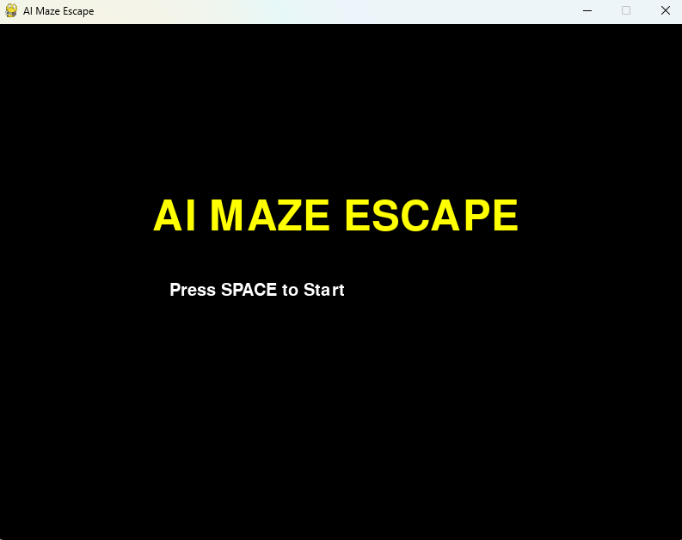

Figure 2: Gameplay Showing the AI Enemy Chasing the Player
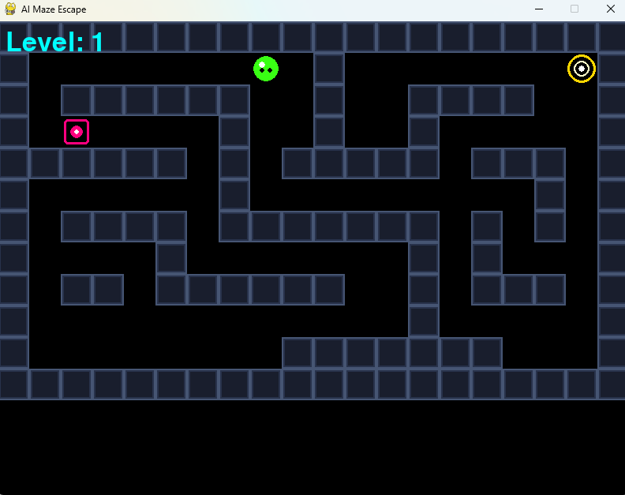

Figure 3: Level 3
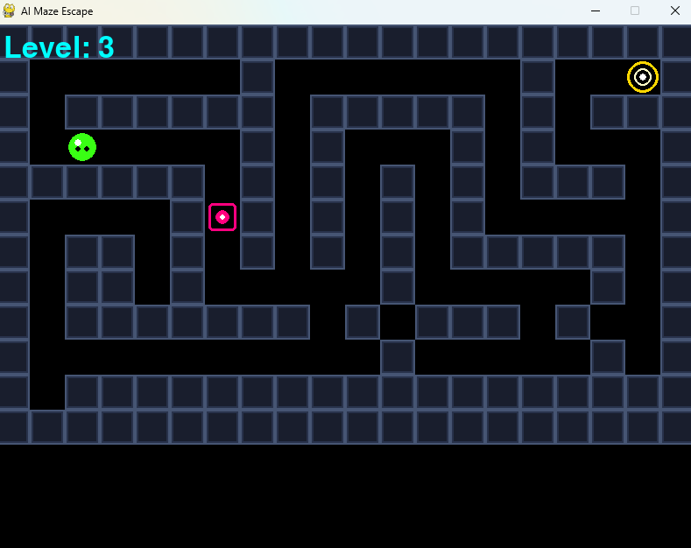
Figure 4: Game Over Screen 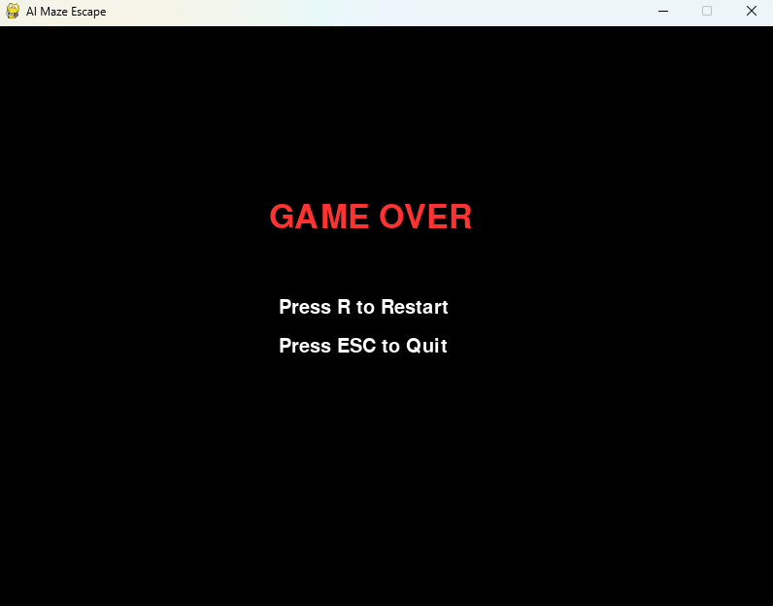

ADVANTAGES
- Demonstrates the use of Artificial Intelligence in games.
- Uses the A* algorithm for efficient pathfinding.
- Provides multiple difficulty levels.
- Improves logical thinking and problem-solving.
- Interactive and easy to play.

LIMITATIONS
- Limited number of levels.
- Basic graphics.
- Only one enemy is present.
- No sound effects or background music.

FUTURE SCOPE
- Add more maze levels.
- Include multiple AI enemies.
- Add sound effects and background music.
- Improve graphics and animations.
- Introduce score and timer system.
- Add different game modes.

CONCLUSION

AI Maze Escape successfully demonstrates the application of Artificial Intelligence in game development. The project uses the A* search algorithm to create an intelligent enemy capable of finding the shortest path to the player. The game combines AI concepts with Python programming and Pygame to create an interactive learning experience. This project also helped improve programming, debugging, and problem-solving skills. The project successfully meets its objectives and demonstrates how Artificial Intelligence can be applied in simple game development.

REFERENCES
- Python Documentation
- Pygame Documentation
- A* Search Algorithm (Research Articles and Educational Resources)
- Stack Overflow (for debugging and learning)
- GitHub Documentation

